Participial Phrase as a modifier

🔹 What Is Participial Phrase as a modifier?
# Source: AI Source: Provided by: [Data Path: Persons Table -> ID Column: 1, Name_En Column: Motasem Essam] -> From: [Chatgpt (GPT‑5 Mini)] on [8/7/2025]
A participial phrase is a group of words that begins with a participle (present or past) and modifies a noun or pronoun by providing additional information about it.
It functions as an adjective in the sentence.

🔸 Structure:
# Source: AI Source: Provided by: [Data Path: Persons Table -> ID Column: 1, Name_En Column: Motasem Essam] -> From: [Chatgpt (GPT‑5 Mini)] on [8/7/2025]
[Participle] + [Modifiers] + [Optional Object]
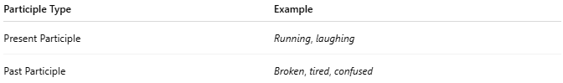
Participle Type | Example
Present Participle | Running, laughing
Past Participle | Broken, tired, confused

🔸 Examples:
# Source: AI Source: Provided by: [Data Path: Persons Table -> ID Column: 1, Name_En Column: Motasem Essam] -> From: [Chatgpt (GPT‑5 Mini)] on [8/7/2025]
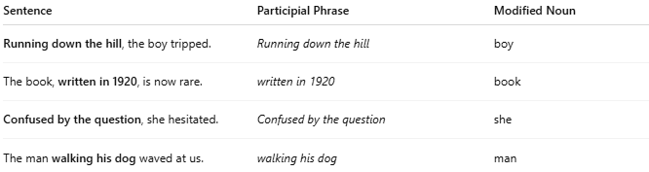
Sentence | Participial Phrase | Modified Noun
Running down the hill, the boy tripped. | Running down the hill | boy
The book, written in 1920, is now rare. | written in 1920 | book
Confused by the question, she hesitated. | Confused by the question | she
The man walking his dog waved at us. | walking his dog | man

🔸 Key Features:
# Source: AI Source: Provided by: [Data Path: Persons Table -> ID Column: 1, Name_En Column: Motasem Essam] -> From: [Chatgpt (GPT‑5 Mini)] on [8/7/2025]
- Always modifies a noun or pronoun
- Can come before or after the noun it modifies
- Acts like an adjective, adding descriptive detail
- Should be placed close to the noun it modifies to avoid misplaced modifiers

⚠️ Common Mistake – Dangling Modifier:
# Source: AI Source: Provided by: [Data Path: Persons Table -> ID Column: 1, Name_En Column: Motasem Essam] -> From: [Chatgpt (GPT‑5 Mini)] on [8/7/2025]
❌ Running to the bus, the bag was left behind.
This sentence wrongly suggests the bag was running.
✅ Corrected: Running to the bus, she dropped the bag.

